Local Area Network (LAN)
A Local Area Network (LAN) is a network that is restricted to smaller physical areas e.g. a local office, school, or house. Approximately all current LANs whether wired or wireless are based on Ethernet.

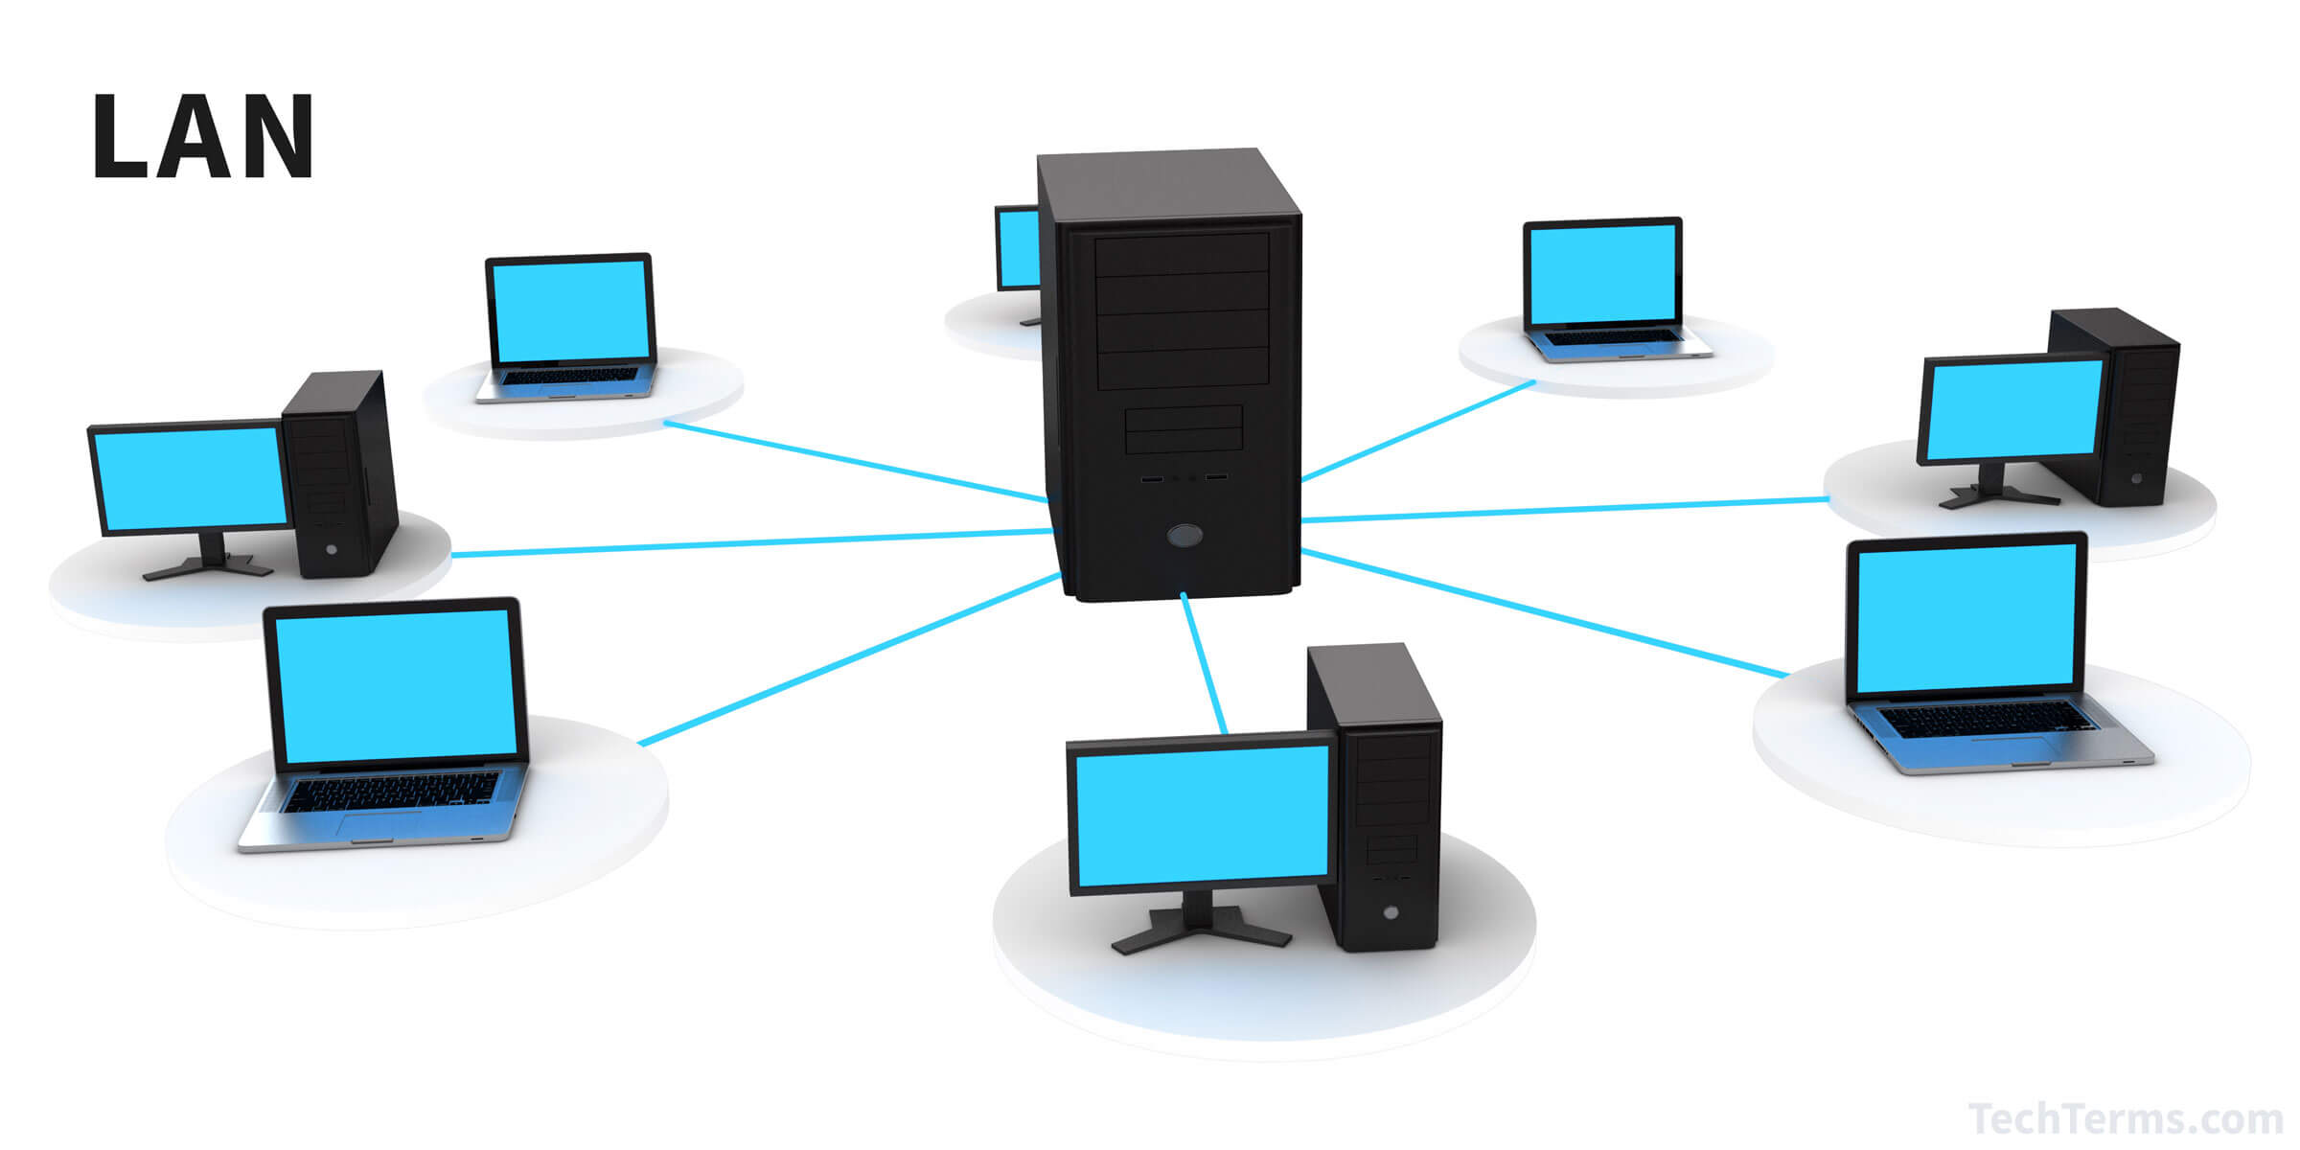

Wide Area Network (WAN)
Wide Area Network is a computer network that covers relatively larger geographical area such as a state, province or country. It provides a solution to companies or organizations operating from distant geographical locations who want to communicate with each other for sharing and managing central data or for general communication.

